FOR IMMEDIATE RELEASE
CONTACT
Amanda Sweet
(347) 564-3371
amanda@bucklesweet.com

CATHEDRAL CHORAL SOCIETY AND WASHINGTON BACH CONSORT
JOIN FORCES TO CELEBRATE BAROQUE MUSIC FROM
MEXICO CITY’S CATHEDRAL
Concert is Sunday Oct. 22 at 4pm at Washington National Cathedral
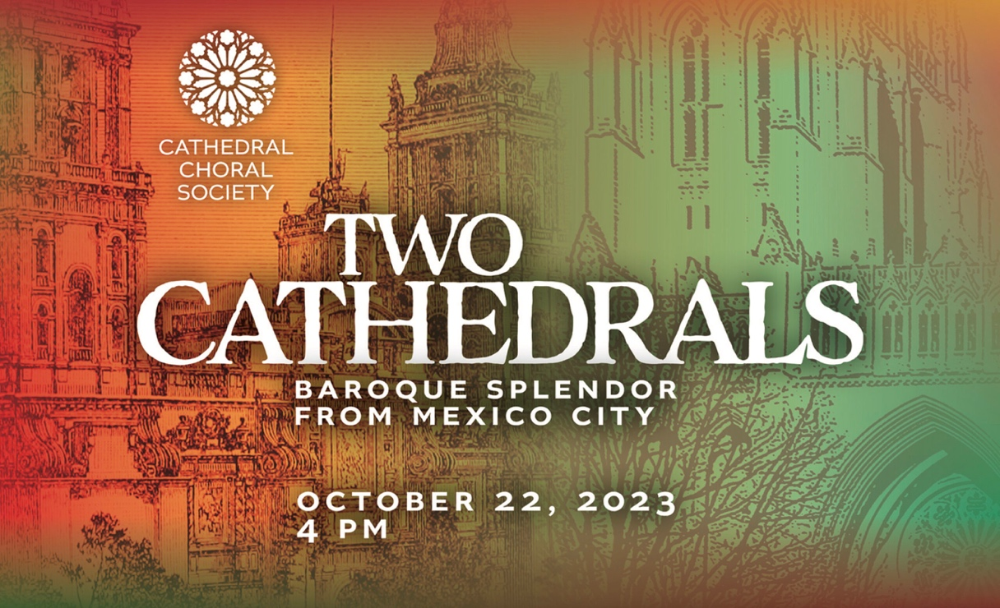

WASHINGTON – The GRAMMY-nominated Cathedral Choral Society (CCS), its Music Director Steven Fox and Washington Bach Consort will present Two Cathedrals: Baroque Splendor from Mexico City on October 22 at Washington National Cathedral (3101 Wisconsin Avenue, NW, Washington, DC). Tickets are $20-98 and can be purchased via: http://cathedralchoralsociety.org/tickets
"There's a great deal of joy in this music,” Fox said. “The brightness of choirs singing in polyphony or in antiphony with each other, together with orchestra, with trumpets and drums, this symbolizes the collision of cultures on this program in such a beautiful way.”
Two Cathedrals: Baroque Splendor from Mexico City celebrates the diverse music of the Catedral Metropolitana de la Asunción de la Bienaventurada Virgen María a los Cielos. The European-style cathedral was built in sections from 1573 to 1813, directly on top of an Aztec temple. The collision of cultures, due to the Spanish’s invasion of the region, resulted in Baroque music with North American influences. CCS and the Washington Bach Consort will perform works by Joan Batista Sanxo, Ignacio de Jerusalem, Manuel de Zumaya and more.
"These composers are not just part of the history of Mexico City. They are part of the history of American music,” Fox said. "Their music came up through the California missions and I think that the repertoire audiences will hear in this concert is actually a very strong part of our American musical heritage."

TWO CATHEDRALS:
BAROQUE SPLENDOR FROM MEXICO CITY
With the Washington Bach Consort
DATE: Sunday, October 22 at 4 PM
Repertoire:
Instrumental Procession from Missa de los Angeles: Joan Batista Sanxo
Kyrie from Missa de Los Angeles: Joan Batista Sanxo
Como Aunque Culpa: Manuel de Zumaya
In horrore visionis: Francisco Lopez Capillas
Gaitas y cumbees: Santiago de Murcia
Kyrie from Misa en Sol: Ignacio de Jerusalem
Versa est in luctum: Juan Gutierrez de Padilla
Sol-fa de Pedro: Manuel de Zumaya
Tarantella: Lucas Ruiz de Ribayaz
Allelulia: Dic Nobis, Maria Capillas
Celebren, publiquen: Manuel de Zumaya
Polychoral Mass in D: Ignacio de Jerusalem
Cathedral Choral Society
As Washington, DC’s oldest symphonic chorus, the GRAMMY-nominated Cathedral Choral Society continues to set the standard for vibrant, engaging concerts in one of the world’s most important places of worship. Each season, CCS presents four mainstage concerts in Washington National Cathedral, and in its programming, the chorus commits itself to presenting works from many musical traditions that challenge, excite, and inspire audiences.

The Washington Bach Consort
The Washington Bach Consort, established in 1977 by J. Reilly Lewis and now led by Artistic Director Dana Marsh, is a professional period choral and orchestral ensemble located in Washington, DC. The Consort is dedicated to upholding the legacy of Johann Sebastian Bach and his contemporaries by performing their music to the highest artistic standards, broadening audiences in the nation’s capital, fostering appreciation through education and community outreach, and interpreting the music of Bach for audiences of today. Critically acclaimed performances, as well as collaborations with major organizations like the Cathedral Choral Society, have established the Consort as a prominent arts organization. Notable recordings include Bach’s Motets, Magnificats by J.S. and C.P.E. Bach, and the first American recording of the F Major and G Minor masses. As part of its dedication to accessibility, the Consort offers free educational programs to Washington’s youth, aiming to make Bach's transformative music available to diverse audiences.

###

